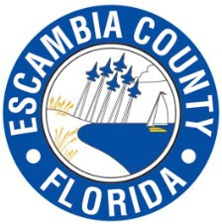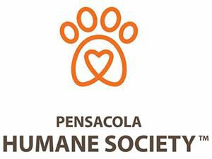
Escambia County Resident Grant
Qualifying Form

Residency and Income Verification
Statement for the Record: I attest to the fact that the information provided on this application is true and accurate to the best of my knowledge. I also attest that the Residency Information provided is true and Income information supplied to the Pensacola Humane Society represents the TOTAL income received by ALL members of my household.

My household's gross annual income is:
My household has adults (any member of the household over the age of 18).

Are you able to provide proof of income for EACH adult member of the household? I am a resident of County, Florida?

Signed

Date:

Printed Name:
Address: City: _ State: Zip_ Phone: Driver’s License/ID#: _St: May we contact you after the surgery is performed to get your feedback? Yes___or No___

For Office Use Only

Staff is required to attach copies of each of the following to this application:
- ID FOR ALL ADULTS IN HOUSHOLD
- Proof of Residence
- Proof of ALL HOUSEHOLD INCOME

*This program is available until funds are depleted. No guarantee of grant funds is made. This program will end upon depletion of funds with no prior notice given.
A partnership with Pensacola Humane Society & Escambia County.

Resident Grant Qualifying Form
Please complete this application to apply for a discounted spay/neuter surgery for your pets. This program does NOT cover the cost of vaccines OR additional services.
This program is ONLY available to residents of Escambia County Florida.

Please bring COPIES OF ALL DOCUMENTS NEEDED TO PROVE ELIGIBILITY FOR ESCAMBIA COUNTY RESIDENTIAL GRANT:
Government issued photo ID
  - Proof of Residence in Escambia County, Fl (must provide one of the following documents).
Utility Bill (power, water, cable or phone. Note: must show SERVICE address not just “bill to” address). – or-
    - Residential Lease Agreement

  - Proof of TOTAL household income (must be below $35,000 combined for ALL household members).
    - Most recent tax returns (2020) (for all members of household) –or-
    - Most recent W-2 (2020) (for all members of household) -or-
    - Most recent pay stubs (for all members of household) –or-
    - Disability Awards Letter
(BANK STATEMENTS CAN NOT BE ACCEPTED AS PROOF OF INCOME)

  - Proof of Vaccinations
* (Any cat/dog that is not accompanied by a CURRENT RABIES VACCINATION CERTIFICATE will be required to receive a rabies vaccination on the day of Surgery for a fee of $15).
*By state law, rabies vaccinations must be given by a licensed veterinarian. Rabies vaccinations given by Pitbull Paradise or given by pet owners are not considered valid.

Animal Name | Species | Gender | Rabies Expires (MM/DD/YY)

NEXT STEPS:
$15 Rabies Vaccination (if applicable)
Cash/Credit/Debit
Schedule your appointment at the Barbara Grice Spay & Neuter Clinic. (850) 898-3380. Please inform the staff that you wish to use the Resident Grant Program. Bring the following with you to your appointment:
Your pet(s) This qualifying form Copies of Proof Documents (ID, Residency, HH Income, Rabies Certificate)

